Kubernetes Task

**Task Description:**

Setup minikube at your local and explore creating namespaces (Go through official documentation).

**Techstacks needs to be used :**

* Vbox, WSL
* Docker
* Minikube
* Kubectl

If the Local system has any issues you can use AWS.

* AWS EC2 (t2.medium)

**Setup minikube at your Local:-**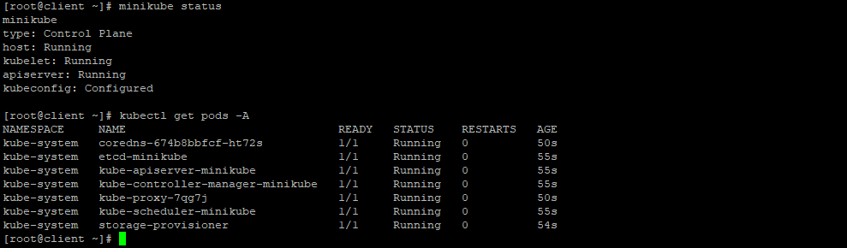

**Creating Name space:**

